**DAILY ONLINE ACTIVITIES SUMMARY**

|  |  |  |  |  |  |  |  |
| --- | --- | --- | --- | --- | --- | --- | --- |
| **Date:** | **04-06-2020** | | | | **Name:** | **Harshitha M** | |
| **Sem & Sec** | **8th ''** | | | | **USN:** | **4AL16CS038** | |
| **Online Test Summary** | | | | | | | |
| **Subject** | | **SMS** | | | | | |
| **Max. Marks** | | **60** | | **Score** | | **60** | |
| **Certification Course Summary** | | | | | | | |
| **Course** | **Python for machine learning** | | | | | | |
| **Certificate Provider** | | | **Great learning** | **Duration** | | | **3hr** |
| **Coding Challenges** | | | | | | | |
| **Problem Statement:Not given** | | | | | | | |
| **Status:Solved** | | | | | | | |
| **Uploaded the report in Github** | | | | **Yes** | | | |
| **If yes Repository name** | | | | **Harshitha-M** | | | |
| **Uploaded the report in slack** | | | | **Yes** | | | |

Online Test Details: (Attach the snapshot and briefly write the report for the same)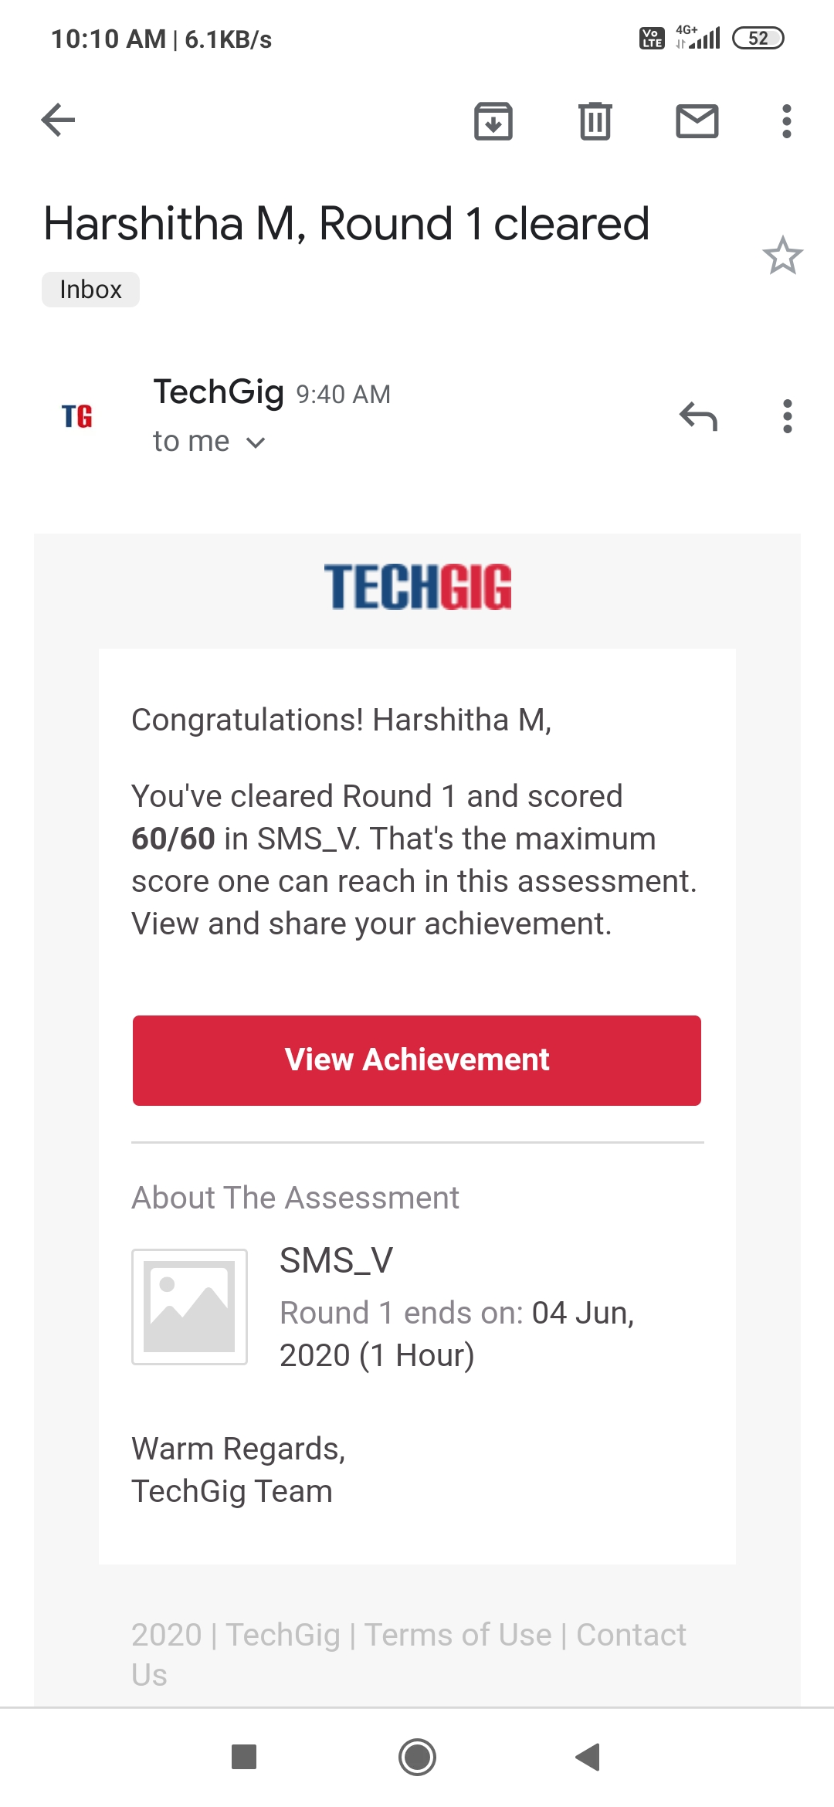

Certification Course Details: (Attach the snapshot and briefly write the report for the same)

